Question 1
Code
public class Question1 {
public static void main(String []args){
//Question 1: Write a Java program to print "Hello, World!" to the console.
System.out.println("Hello World");
}
}

Output
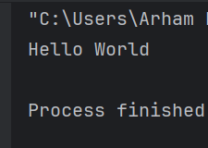
Question 2
Code
import java.util.Scanner;
public class VariableDemo {
public static void main(String []args){
Scanner input=new Scanner(System.in);
System.out.print("Enter Your Name: ");
String name=input.nextLine();
System.out.print("Enter Your Age: ");
int age= input.nextInt();
System.out.println("Name: "+name+" Age: "+age);
}
}

Output
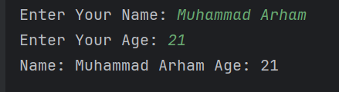

Question 3
Code
import java.util.Scanner;
public class Question3 {
// Sum of two Numbers
public double calculateSum(double number1,double number2){
return number1+number2;
}
// Subtract of Two Numbers
public double calculateSubtraction(double number1,double number2){
return number1-number2;
}
// Multiplication of Two Numbers
public double calculateMultiplication(double number1,double number2){
return number1*number2;
}
// Division Of Two Numbers
public double calculateDivision(double number1,double number2){
return number1/number2;
}
public static void main(String []args)
{
Scanner input=new Scanner(System.in);
Question3 obj=new Question3();
System.out.print("Enter The Number-1: ");
double number1=input.nextDouble();
System.out.print("Enter The Number-2: ");
double number2=input.nextDouble();
double sum = obj.calculateSum(number1, number2);
double sub = obj.calculateSubtraction(number1, number2);
double mul = obj.calculateMultiplication(number1, number2);
double div = obj.calculateDivision(number1, number2);
System.out.println("Sum = " + sum);
System.out.println("Subtraction = " + sub);
System.out.println("Multiplication = " + mul);
System.out.println("Division = " + div);
}
}

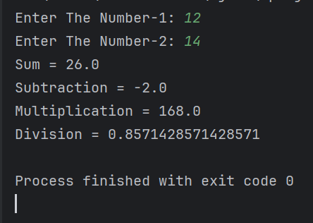
Output

Question 4
Code
import java.util.Scanner;
public class Question4 {
public void sumOfAllArray(int []arr,int size){
int sum=0;
for (int i=0;i<size;i++){
sum+=arr[i];
}
System.out.println("Total Sum: "+sum);
}
public static void main(String[]args){
Question4 obj=new Question4();
Scanner input=new Scanner(System.in);
System.out.print("Enter The Size Of Your Array: ");
int size=input.nextInt();
int [] array=new int[size];
// Input Get From the User
for (int i=0;i<size;i++){
System.out.print("Enter No-"+(i+1)+" : ");
array[i]=input.nextInt();
}
obj.sumOfAllArray(array,size);
}
}

Output
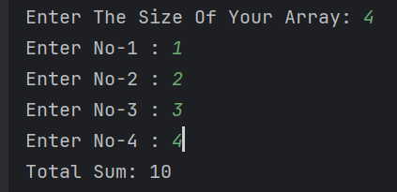

Question 5
Code
import java.util.Scanner;
public class Question5 {
public void checkEvenOrOdd(int number){
if (number%2==0){
System.out.println("Number "+number+" Is Even");
}else {
System.out.println("Number "+number+" Is Odd");
}
}
public static void main(String[]args){
//Question 5: Write a Java program to check whether the number entered by user is even or odd.
Question5 obj=new Question5();
Scanner input=new Scanner(System.in);
System.out.print("Enter Your Number: ");
int number=input.nextInt();
obj.checkEvenOrOdd(number);
}
}

Output
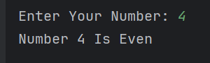

Question 6
Code
import java.util.Scanner;
public class Question6 {
public void factorial(int number){
int fact=1;
for (int i=1;i<=number;i++){
fact*=i;
}
System.out.print("Factorial Of "+number+" is "+fact);
}
public static void main(String [] args){
Question6 obj=new Question6();
Scanner input=new Scanner(System.in);
System.out.print("Enter Your Number: ");
int number=input.nextInt();
obj.factorial(number);
}
}

Output
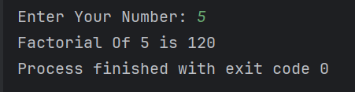

Question 7
Code
import java.util.Scanner;
public class Question7 {
public void leapYear(int year){
if ((year%4==0&&year%100!=0)||(year%400==0)){
System.out.print(year+" is a Leap Year");
}else {
System.out.print(year+" is not a Leap Year");
}
}
public static void main(String[]args){
Question7 obj=new Question7();
Scanner input=new Scanner(System.in);
System.out.print("Enter Your Number: ");
int year=input.nextInt();
obj.leapYear(year);
}
}

Output
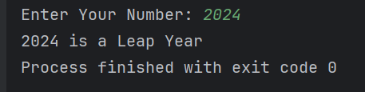
Question 8
Code
import java.util.Scanner;
public class Question8 {
public void findElementInArray(int []arr,int size,int search){
boolean check=false;
int i;
for (i=0;i<size;i++){
if (arr[i]==search){
check=true;
break;
}
}
if (check){
System.out.print("Number "+search+" Is Found In Array at index "+i);
}else {
System.out.println("Number Can't Be Found");
}
}
public static void main(String[]args) {
Question8 obj = new Question8();
Scanner input = new Scanner(System.in);
System.out.print("Enter The Size Of Your Array: ");
int size = input.nextInt();
int[] array = new int[size];
// Input Get From the User
for (int i = 0; i < size; i++) {
System.out.print("Enter No-" + (i + 1) + " : ");
array[i] = input.nextInt();
}
System.out.print("Enter The Search No: ");
int search = input.nextInt();
obj.findElementInArray(array, size, search);
}
}

Output
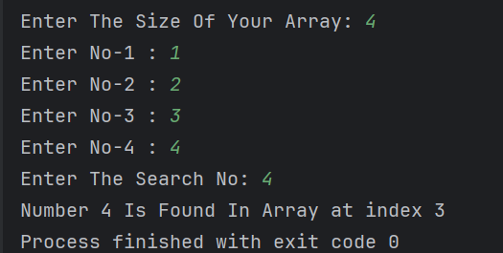

Question 9
Code
public class Question9 {
public static void main(String[] args) {
for (int num = 2; num <= 100; num++) {
boolean isPrime = true;
for (int i = 2; i <= num / 2; i++) {
if (num % i == 0) {
isPrime = false;
break;
}
}
if (isPrime) {
System.out.print(num + " ");
}
}
}
}

Output

Question 10
Code
public class Question10 {
public static void main(String[]args){
//Question 10: Write a program that calculates the sales tax and
// service fee on a $120.00 concert ticket.
// The sales tax should be 7.5 percent of the ticket price.
// The service fee should be 10 percent of the total after adding the tax.
// Display the ticket price, tax amount,
// service fee amount, and total cost on the screen.
double ticketPrice=120.00;
double salesTax=ticketPrice*0.075;
double serviceFee=(ticketPrice+salesTax)*0.10;
double totalCost=ticketPrice+salesTax+serviceFee;
System.out.println("Ticket Price: $" + ticketPrice);
System.out.println("Sales Tax (7.5%): $" + salesTax);
System.out.println("Service Fee (10%): $" + serviceFee);
System.out.println("Total Cost: $" + totalCost);
}
}

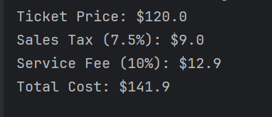
Output

Question 11
Code
import java.util.Scanner;
public class Question11 {
public static void main(String[]args){
//Question 11: Write a Java program to print Floyd’s triangle
Scanner input=new Scanner(System.in);
System.out.print("Enter The Number of Rows: ");
int row=input.nextInt();
int number=1;
for (int i=1;i<=row;i++){
for (int j=1;j<=i;j++){
System.out.print(number+" ");
number++;
}
System.out.println();
}
}
}

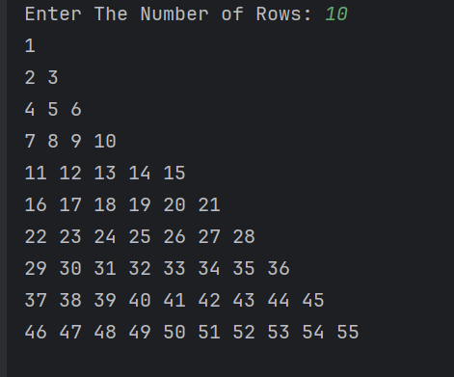
Output

Question 12
Code
public class Question12 {
private String registrationNumber;
private double price;
private String ownerName;
// Constructor
public Question12(String registrationNumber, double price, String ownerName) {
this.registrationNumber = registrationNumber;
this.price = price;
this.ownerName = ownerName;
}
// Getter and Setter methods
public String getRegistrationNumber() {
return registrationNumber;
}
public void setRegistrationNumber(String registrationNumber) {
this.registrationNumber = registrationNumber;
}
public double getPrice() {
return price;
}
public void setPrice(double price) {
this.price = price;
}
public String getOwnerName() {
return ownerName;
}
public void setOwnerName(String ownerName) {
this.ownerName = ownerName;
}
// Display method
public void displayInfo() {
System.out.println("Registration Number: " + registrationNumber);
System.out.println("Price: $" + price);
System.out.println("Owner Name: " + ownerName);
}
public static void main(String[] args) {
Question12 car = new Question12("L1F23BSSE0372", 25000, "Arham Bhatti");
car.displayInfo();
}
}

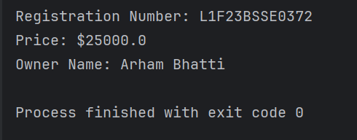
Output

Question 13
Code
public class Question13 {
private double base;
private double height;
// Constructor
public Question13(double base, double height) {
this.base = base;
this.height = height;
}
// Getter and Setter
public double getBase() {
return base;
}
public void setBase(double base) {
this.base = base;
}
public double getHeight() {
return height;
}
public void setHeight(double height) {
this.height = height;
}
// Method to calculate area
public double calculateArea() {
return 0.5 * base * height;
}
public static void main(String[] args) {
Question13 triangle = new Question13(10, 5);
System.out.println("Area of triangle: " + triangle.calculateArea());
}
}

Output
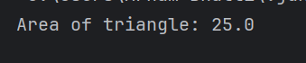
Question 14
Code
public class Question14 {
private String name;
private int age;
private char grade;
// Constructor
public Question14(String name, int age, char grade) {
this.name = name;
this.age = age;
this.grade = grade;
}
// Getters and Setters
public String getName() {
return name;
}
public void setName(String name) {
this.name = name;
}
public int getAge() {
return age;
}
public void setAge(int age) {
this.age = age;
}
public char getGrade() {
return grade;
}
public void setGrade(char grade) {
this.grade = grade;
}
public void displayInfo() {
System.out.println("Name: " + name);
System.out.println("Age: " + age);
System.out.println("Grade: " + grade);
}
public static void main(String[] args) {
Question14 student = new Question14("Arham", 20, 'A');
student.displayInfo();
}
}

Output
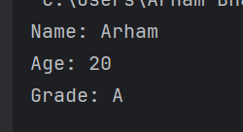
Question 15
Code
class Question15_BankAccount {
private String accountNumber;
private double balance;
private double interestRate;
public Question15_BankAccount(String accountNumber, double balance, double interestRate) {
this.accountNumber = accountNumber;
this.balance = balance;
this.interestRate = interestRate;
}
public void deposit(double amount) {
balance += amount;
System.out.println("Deposited: $" + amount + " | New Balance: $" + balance);
}
public double getBalance() {
return balance;
}
}
class Question15_SavingsAccount extends Question15_BankAccount {
private double minimumBalance;
public Question15_SavingsAccount(String accountNumber, double balance, double interestRate, double minimumBalance) {
super(accountNumber, balance, interestRate);
this.minimumBalance = minimumBalance;
}
// Withdraw method
public void withdraw(double amount) {
if (getBalance() - amount >= minimumBalance) {
deposit(-amount);
} else {
System.out.println("Cannot withdraw! Minimum balance requirement.");
}
}
}
public class Question15 {
public static void main(String[] args) {
Question15_BankAccount bankAcc = new Question15_BankAccount("BA1001", 5000, 3.5);
bankAcc.deposit(1000);
Question15_SavingsAccount savingsAcc = new Question15_SavingsAccount("SA2001", 2000, 4.0, 500);
savingsAcc.deposit(500);
savingsAcc.withdraw(1000);
savingsAcc.withdraw(1500);
}
}

Output
